**NOISE POLLUTION MONITORING**

**INTRODUCTION**

Noise pollution refers to the excessive, displeasing, or disruptive sound that interferes with normal activities, causing harm to human health and the environment. It often results from various sources, including transportation, industrial processes, construction, and recreational activities, and can have detrimental effects on physical and mental well-being, as well as wildlife and ecosystems. Managing and mitigating noise pollution is crucial for maintaining a healthy and peaceful living environment. Noise pollution monitoring is the systematic process of measuring, assessing, and managing excessive and unwanted noise in our environment. It involves the use of specialized equipment and techniques to quantify noise levels, identify sources of noise pollution, and evaluate its impact on human health and well-being. This vital field plays a crucial role in urban planning, public health, and environmental management by providing data and insights to mitigate the adverse effects of noise pollution on society. Monitoring noise pollution is crucial for maintaining the well-being of urban environments. Various methods are employed to assess noise levels in different areas. Sound level meters, equipped with microphones, record sound intensity and frequency, while data loggers collect continuous measurements over time. Noise mapping combines this data to create visual representations of noise distribution across regions, aiding in pinpointing trouble spots. Additionally, community involvement is essential, with citizen science initiatives and mobile apps allowing residents to contribute noise data. These monitoring efforts help authorities implement effective noise control policies and protect the health and tranquility of communities.

**ABSTRACT**

Noise pollution, also known as environmental noise, is the presence of unwanted or excessive sound in the environment that can be harmful or disruptive to human health, well-being, or the natural world. Here are some details about noise pollution: Sources of Noise Pollution: Noise pollution can originate from various sources, including transportation (e.g., traffic, aircraft, and trains), industrial activities (e.g., factories and construction sites), recreational activities (e.g., loud music and sports events), and even from neighbors or household appliances. Effects on Health: Prolonged exposure to high levels of noise pollution can have adverse health effects. It can lead to stress, sleep disturbances, hearing loss, and increased risk of cardiovascular problems like hypertension and heart disease. It may also impair cognitive functions and hinder concentration and communication. Environmental Impact: Noise pollution can disrupt natural ecosystems and wildlife. It can interfere with animal communication, navigation, and breeding patterns. For example, marine animals like whales and dolphins rely on sound for various activities, and underwater noise pollution from ships and drilling can be detrimental to them. Regulations and Standards: Many countries have regulations and noise standards in place to mitigate noise pollution. These regulations often specify acceptable noise levels for different times of the day and in various areas, such as residential, industrial, or commercial zones. Control Measures: Noise control measures include using sound barriers (like walls and acoustic panels), implementing noise-reducing technologies in transportation and industry, and zoning restrictions to separate noisy activities from quiet areas. Personal Protection: Individuals can protect themselves from noise pollution by using earplugs or noise-canceling headphones, reducing exposure to loud environments, and advocating for noise reduction in their communities. In summary, noise pollution is a pervasive environmental issue with significant implications for human health and the natural world. Efforts to control and reduce noise pollution involve a combination of regulations, technology, public awareness, and personal actions to create quieter and healthier living environments.

**DESIGN**

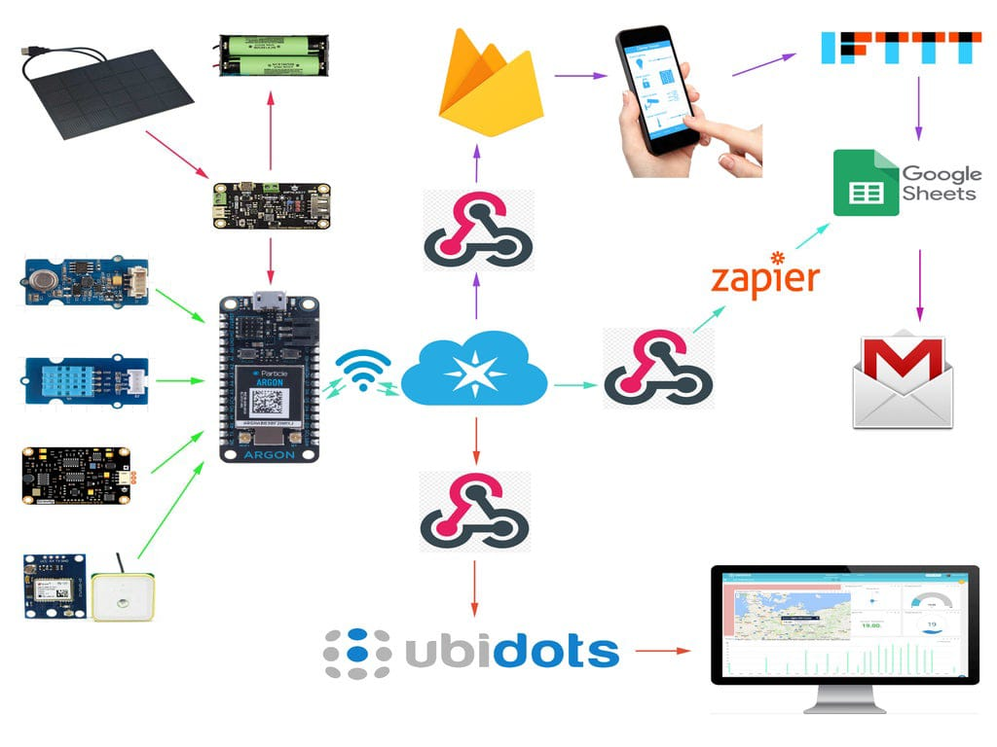**METHODOLOGY**

Monitoring noise pollution involves a systematic approach to measure, assess, and manage noise levels in various environments. Here's a detailed methodology for noise pollution monitoring: Clearly define the objectives of your noise monitoring project. Identify the locations where you will conduct noise measurements. These should be representative of the areas you want to assess. Consider factors like proximity to noise sources, potential impact on residents, and land use. Select appropriate noise monitoring equipment. Common tools include sound level meters (SLMs) or noise dosimeters. Ensure that the equipment meets relevant standards and is calibrated regularly. Calibrate the monitoring equipment according to manufacturer guidelines and applicable standards. Calibration ensures accurate measurements. Place the monitoring equipment at predetermined locations and heights to collect data. Ensure that equipment is set up correctly and securely. Record data continuously or at regular intervals, depending on your objectives. Analyze the collected data using specialized software or tools. Calculate various noise metrics, such as L10 (the noise level exceeded for 10% of the time), L50 (the median noise level), and L90 (the noise level exceeded for 90% of the time). Create noise maps using geographical information systems (GIS) to visualize noise levels spatially. This helps identify noise hotspots and areas where noise pollution exceeds permissible levels. Identify the sources of noise pollution in the monitored area. This may involve on-site inspections or consultation with experts in noisInterpret the data in the context of local regulations and guidelines. Determine if noise levels exceed permissible limits and assess their impact on human health and the environment.e control. Prepare a comprehensive noise pollution report summarizing your findings. Include details about monitoring locations, equipment used, data analysis, noise sources, and any recommendations for noise reduction or control measures. Engage with the community to raise awareness about noise pollution and involve them in decision-making processes regarding noise control. Continuous monitoring and assessment are crucial for effectively managing and mitigating noise pollution to create healthier and more livable environments. Adjust your methodology based on the specific objectives and context of your noise pollution monitoring project

**RELATED IMAGES**



**CONCLUSION**

In conclusion, noise pollution is a pressing environmental issue with far-reaching impacts on human health, well-being, and the environment. It disrupts our daily lives, contributes to various health problems, and disturbs ecosystems. Addressing noise pollution requires a combination of effective regulations, responsible urban planning, and individual efforts to reduce noise at its source. By taking action to mitigate noise pollution, we can create quieter, more peaceful communities and safeguard our health and the environment for future generations. Noise pollution monitoring is crucial for assessing and managing the impact of excessive noise on the environment and human health. Through effective monitoring, we can identify noise sources, measure their intensity, and take appropriate measures to mitigate their effects. This process is essential for creating quieter, healthier, and more sustainable communities in the future.

**THANK YOU**